Website MVP Simplified PRD v2

Home Page
Centered Search Bar
Placeholder:
- Option A (Playful): "See what our AI thinks of a researcher..."
Autocomplete:
Dropdown list of potential matches, including affiliation for duplicate names
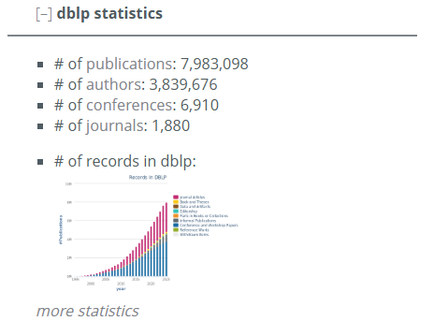
Database Statistics Dashboard
- Number of Researchers Indexed
- Number of Papers Analyzed
- Number of Premier Venues Covered
- Simple minichart – year by year publication count
Leaderboard Previews
- Featured metrics:
  - ANCI (Industry recognition),
  - Accel (future star)
  - PQI etc.
- More metrics, expand to show other metrics
- Small card showing top 5 names on each leaderboard
- View full leaderboard call to action button, redirect to full leaderboard
Spotlight Section
- Routinely select random author from leaderboard
- Display top 1 author of a random metric
  - Can click into the author home page

Leaderboard Page
Dynamic Selector
- Compact collective view of all leaderboards (redirected from navigation bar)
- Intuitive way to switch between different leaderboards
- Clickable tabs with core metric name
- Hover-over brief description of metric: calculated using … metrics, suggests …
Row Design
- Rank – bold number
- Author full name
- Current affiliation
- Key metric score, column highlighted
- Secondary supporting metrics:
  - paper count, citation count, career length, other intermediate metrics
- View profile button – far right of table, redirects to author profile page
Filtering
- By affiliation
- By career stage (<5yrs, 5-15yrs, etc.)
- Ascending/descending sort
Icon Indicators
- Rising star, field pioneer, need to come up with specific author ‘tags’

Author Profile Page
Header
- Profile pic (Future: LLM Generate, placeholder; 统一风格，名字affliation)
- Full Name
- Affiliation
- Homepage link if available
- Quick context career stats: career length, publication count, citation count
- Speech bubble with AI-generated brief summary/analysis/comment in layman language
Comprehensive Metrics Dashboard (on hold)
- Calculated metrics numerical overview
- Yearly citation graph
- Interactive coauthor network
  - Author nodes with initials
  - Links with varying thickness depending on co-op strength
  - Hover over to show summary card with full name, number of papers coauthored,
  - Perhaps an influence score? (Contribution to main author’s total citations: sum of coauthored paper cites/ main author total cites, normalized across cuauthors)
  - Indicate students and advisor nodes if possible

Publication History
- Paper entry: title, venue, year, citations, award emoji (click to see award details)
- Interactive expand row to reveal author list (current author highlighted), and abstract
- Default to sorted by citations, allow custom sort by year or venue
Other Functions
- Redirect to compare researcher page

Navigation Bar
- Logo (Return to homepage)
- Leaderboards (dropdown)
- Affiliations (dropdown)
- Compare (redirect to compare page)
- Methodology

Helpful Designs
- Dark Mode/Theme Toggle
- Multilingual
- Share

6 Point Radar Graph
Assesses author capabilities
- Impact – overall citation related metrics
- Productivity – output/career length
- Quality – pqi score?
- Momentum – career trajectory
- Collaboration – network size and strength
- Influence – network centrality

